EB359 FA23 IMC Project Proposal - Sun Motor Cars
by Media Department - Daphne, Giselle, Chloe

0.5. MEMBERS:
- Daphne Pham
  - POE: Marketing
  - Specialty: Social Media Marketing
- Chloe Webb
  - POE: Psychology (Sec. Marketing and IMA)
  - Specialty: Graphic Communications
- Giselle Godinez
  - POE: Marketing, Politics
  - Speciality: Small business marketing

- EXECUTIVE SUMMARY:
Sun Motor Cars is a family owned business with a 37-year legacy. It stands as a beacon of quality, community, and care services in the automotive industry. Located in Central Pennsylvania, and headed by Dan Sunderland, the company embraces a media-forward approach, making use of platforms such as Facebook and Instagram to show brand-focused advertising. Dan’s personal connection and commitment to the company is potent, with his passion reflecting the cherished memories of his father and dedication to upholding his legacy.
At Sun Motor Cars, the community is at the heart of everything. Their active involvement in local schools and charitable initiatives underscores their commitment to giving back. Employees are more than just staff members; The company's commitment to their employees’ well-being accentuates their people-centric approach, prioritizing a healthy work environment over a pursuit of profit. Knowing that employees are integral to crafting exceptional customer experiences. German engineering excellence underlines Sun Motor Cars’ offerings, encompassing brands such as Mercedes, BMW, and Audi. The company offers a variety of services, spanning over sales, leasing, service, parts, and accessories, all located conveniently at Mechanicsburg, PA. This all-in-one approach shows their dedication to providing a seamless, reliable, and top-tier automotive solution.

- CURRENT SITUATION Industry Background (e.g. What is the industry background and trend of your company/product/service?)
- Founding and History: Sun Motor Cars was founded 37 years ago as a family-owned and operated business. Throughout its existence, the company has maintained a strong, family-oriented ideology. This commitment to family values has been a driving force behind the company's success, living up to the Sunderland's legacy.
- Geographic Coverage: The company is located in Mechanicsburg, Pennsylvania, specifically on Carlisle Pike. Their primary geographical coverage extends to the surrounding areas of Central PA. Including towns and communities near Mechanicsburg, ensuring convenient access to their dealership for current and potential customers.
- Automotive Services: Sun Motor Cars provides a wide-range of automotive services, making it a convenient one-stop spot for customers. They offer sales, leasing, service, parts and accessories, and a collision center.
  - Sales: The company offers a diverse selection of vehicles from reputable brands such as Mercedes, BMW, and Audi for customers to purchase.
  - Leasing: They provide leasing options for customers who would prefer a more flexible approach to vehicle ownership.
  - Service: Sun Motor Cars has a service center staffed with trained technicians who handle a variety of maintenance and repair tasks. This would include services like oil changes, tire rotations, and more.
  - Parts and Accessories: Customers can access genuine parts and accessories for their vehicles, ensuring that any replacements or enhancements meet, or go beyond, manufacturing standards.
  - Collision Center: Sun Motor Cars has a dedicated Collision Center, demonstrating their ability to handle auto body repair and restoration work.
- Community-Oriented: Sun Motor Cars shows commitment to community involvement through various initiatives, such as charitable donations. Additionally, the company takes a proactive role by engaging with local schools, further strengthening their ties within the community.

  - Company Snapshot (e.g. When/why/how did your company/product/service start? And who was/were involved?)
- Klare Sunderland, father to current owner Dan Sunderland, started in the car business in the 1950s. The first dealership he purchased was a chevy dealership in 1969. He then decided to get into the luxury market when he purchased Meyers Mercedes Benz (where he opened sun motor cars in January of 1983). They started with 12 new and used cars in the lot because it was initially a small dealership site. At the time they were only selling six models, three being diesel. The building didn't look like a car dealership. It was sold later on and they established themselves in their current location.

  - Brand Review (e.g. Is the brand of your company/product/service well-known?)
- Their reach is far in the community. Customers come hours away to purchase a car from them and Sun Motors has strong ties to Juniata College staff. The huntingdon area knows them well and their reach in the community is strong.

  - Competitive Review (e.g. Who are the competitors of your company/product/service?)
- Keystone Classics and Exotic
- Mercedes-Benz of State College
- Sunset Imports Inc
- Xtreme Luxury Auto Sales

  - Buyer Analysis (e.g. Who are the buyers of your company/product/service? What do they need/want?)
- The buyers include:
  - People between the ages of 25-44 (average)
  - Gen Z and Millenials are more likely to purchase luxury vehicles
  - Members of the community they are holding events for
  - Past customers who are looking to get a different service

  - SWOT Analysis of your business:
- Strengths:
  - Have 37 years of based in central PA
  - Great customer service system
  - Skillful and experienced workforce with their loyal customers since their first car they bought at their dealership until now
  - Well-facilitated and well-equipped with skillful technicians garages
- Weaknesses:
  - Have struggles in adapting with new technology and revolution like social media.
  - They are not the only dealership in the media
- Opportunities:
  - Expand and Enhance their online presence on social media platforms as well as websites, YouTube
  - Collab and Have long-term contracts with local businesses that have same core values and missions with Sun Motors Car
- Threats:
  - The appearance of new dealership type is online dealership
  - Changes in economic activities like the financial crisis and authority regulation
Customer Expectations:
- Cars with high-quality, great service that goes with the price as well as the car brand name
- Customer services before, during, and after buying a car.
IMC PROMOTIONAL PROGRAM OBJECTIVES
2.1 Target Market (Daphne)
Sun Motor Cars likely targets a market segment that values innovation, environmental sustainability, and advanced technology, given their focus on solar-powered vehicles. This demographic tends to include environmentally conscious consumers, tech enthusiasts, and early adopters of green technology. Additionally, if Sun Motor Cars offers luxury features or premium design, the target market may also extend to affluent customers who prioritize exclusivity and prestige in their vehicle choices. This diverse target market reflects a growing interest in eco-friendly transportation solutions combined with a desire for high-quality, technologically advanced vehicles.
2.2 IMC Objectives (SMART) (Dạphne)
Specific

Increase Sun Motor Cars' market penetration in the eco-friendly vehicle segment by 25% within the next 18 months. This can be achieved by launching targeted marketing campaigns that emphasize the unique benefits of solar-powered vehicles, such as environmental sustainability and cost savings, through digital platforms, eco-focused events, and collaborations with green organizations.

Measurable

Boost the number of visitors to Sun Motor Cars' website by 40% over the next nine months through strategic digital marketing. This goal will involve a robust mix of SEO, engaging social media content, influencer partnerships, and interactive online campaigns focused on the benefits and features of solar-powered cars.

Achievable

Increase Sun Motor Cars' customer base by 20% in the next year, focusing on markets with high environmental awareness and potential tax incentives for eco-friendly vehicle purchases. This objective considers the current market trends in eco-friendly vehicle demand and Sun Motor Cars' production capabilities.

Relevant

Improve customer loyalty and brand advocacy by 15% within the next year by enhancing the customer experience. This includes offering exceptional post-purchase support, creating community forums for solar vehicle enthusiasts, and providing exclusive updates and benefits to existing customers. This strategy aligns with Sun Motor Cars' commitment to building a sustainable brand community.

Time

Launch a new solar-powered vehicle model and achieve a sales target of 10,000 units within the first six months of its release. This objective is timed to coincide with major environmental events and will be supported by a comprehensive marketing campaign that includes previews at eco-friendly expos, digital teasers, and collaborations with environmental influencers.
3. IMC PROMOTIONAL PROGRAM
3.1 Positioning and Campaign Theme (Daphne)
Sun Motor Cars positions itself as a leader in eco-innovative luxury, blending environmental sustainability with premium design. The campaign theme, "Drive the Sun: Elegance Meets Ecology," emphasizes this unique blend, targeting discerning customers who value both ecological responsibility and luxury. The campaign will feature visually striking imagery, narrative storytelling, strategic partnerships, interactive experiences, and a strong digital presence, all underscoring the message that owning a Sun Motor Car is a lifestyle choice for a sustainable and luxurious future.
3.2 Creative Recommendations
3.2.1 Unique Selling Proposition (Daphne)
The unique selling proposition (USP) of Sun Motor Cars Dealership centers on offering an exclusive range of solar-powered vehicles that combine cutting-edge renewable energy technology with luxury and performance. This dealership stands out by providing customers with an innovative and environmentally responsible driving experience without sacrificing style or comfort. Sun Motor Cars Dealership not only sells vehicles but also embodies a commitment to sustainability, showcasing how luxury and eco-friendliness can coexist seamlessly. Their USP is the promise of a forward-thinking, green automotive lifestyle, appealing to those who seek to make a positive environmental impact while enjoying the latest in automotive luxury and technology.
3.3 The IMC Mix
3.3.1 Advertising Media Recommendations (Chloe)
Sun Motor Cars can significantly enhance their advertising strategy by expanding their social media presence, especially on platforms such as Instagram and TikTok. Thus, targeting the younger end of SMC’s target audience. While FaceBook is currently in use, optimizing its advertising capabilities will help to amplify brand visibility and allow better promotion of special offers. SMC could also collaborate with other creators and brands in order to reach a broader audience by adding more overall content. Moreso, making the website more interactive and centralized would add a more modern and smooth experience. These strategies overall aim to widen Sun Motor Cars’ outreach and maintain a competitive edge in the central Pennsylvania automotive market.
3.3.2 Sales Promotions Recommendations (Daphne)
3.3.2.1 Consumer
For Sun Motor Cars, consumer-focused sales promotions could include offering a free solar charging station with purchases during a limited-time period, a referral rewards program for existing customers, and additional trade-in bonuses for those switching from gasoline vehicles. Also, engaging test drive contests, special financing and leasing deals, an eco-loyalty program rewarding sustainable practices, and seasonal campaigns aligned with environmental events could be highly effective. These promotions are tailored to emphasize Sun Motor Cars' unique blend of luxury, eco-friendliness, and advanced technology, appealing to a broad range of environmentally conscious customers.
3.3.3 Direct Marketing Recommendations (Daphne)
For Sun Motor Cars, direct marketing could involve personalized email campaigns that highlight the unique aspects of their solar-powered vehicles, coupled with eco-friendly direct mail featuring interactive elements like QR codes for virtual experiences. Additionally, leveraging SMS marketing for timely offers and updates, alongside a customer referral program to incentivize word-of-mouth, can be effective. Hosting exclusive webinars or virtual events to showcase new models and features can further engage potential customers, providing a direct and immersive brand experience.
3.3.4 Internet/ Interactive Recommendations (Giselle)
3.3.5 Public Relations Recommendations
Sun Motor Cars must advertise their interactions with other businesses on their social media outlets because although they do many things in the community, it has been admitted that their silent contributions in the past did not do anything for their image. If the reach to a farther clientele is important, partnering with businesses in the Huntingdon Country area could strengthen their relationship with distanced communities. Because they are farther away, being more involved in the Huntingdon community could allow them to branch farther away from their own bubble.
3.3.6 Personal Selling Recommendations
Sun Motor Cars has done a successful job in terms of personal selling. They are friendly and welcoming to those who are visiting for the first time and much more for those who have come before. Knowing people’s names and remembering small parts of their lives are key to strong relationships and returning customers. There is not much to do but continue the amazing customer service and overall experience of interacting with Sun Motor Cars.
4. PROMOTIONAL BUDGET (Chloe)
For Sun Motor Cars, we believe that the Task Method would likely work best as the promotional budget. This method aligns the budget with specific goal-oriented tasks, which are essential for achieving the desired promotional and sales objectives. Given how the automotive industry is rather competitive, focusing SMC’s resources on well-outlined tasks ensures a more targeted and effective budget allocation. While the Percentage of Sales method could be a close contender, its reliance on historical figures may limit its adaptability when it comes to market changes. The Task Method, on the other hand, allows for agility in responding to these shifts in the automotive landscape, making it a suitable choice for Sun Motor Cars and their promotional efforts.
5. MEASUREMENT AND EVALUATION (Chloe)
Evaluating the effectiveness of an advertising campaign is crucial for Sun Motor Cars to gauge their impact in the competitive automotive industry. With a focus on luxury vehicles, Sun Motor Cars can assess their campaigns success by tracking customer engagement, both with existing clients and new possible clients. Given the localized scope of their operations, demographic information is more localized, making it easier to measure campaign resonance locally. One way would be to analyze the influx of customers and potential clients to their dealership while running a specific campaign. Next, could be to measure the traffic on their website during a specific campaign. These should show flexibility and be subject to an evaluation of longevity. That way the advertisement avoids becoming stale and reliant on seasonal themes. Thus, losing relevance quickly. Using various channels and diverse strategies will enable SMC to use the most effective approaches for their brand. Overall, an evaluation system will empower the company to refine their advertising strategies and optimize their impact in the luxury automotive market.
6. APPENDICES
6.1 Commercials
- 1:14 - https://youtu.be/RMOIM4EJttM
- 0:48 - https://youtu.be/1Dlb16ObKEo
6.2 Advertising Materials


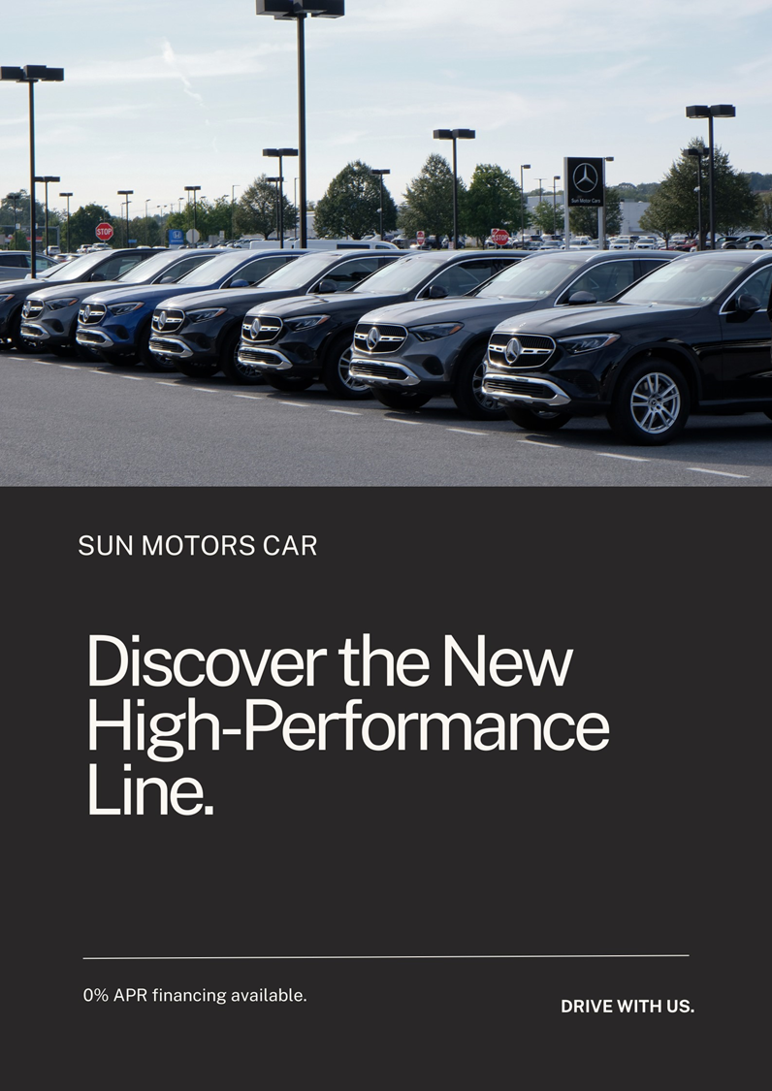

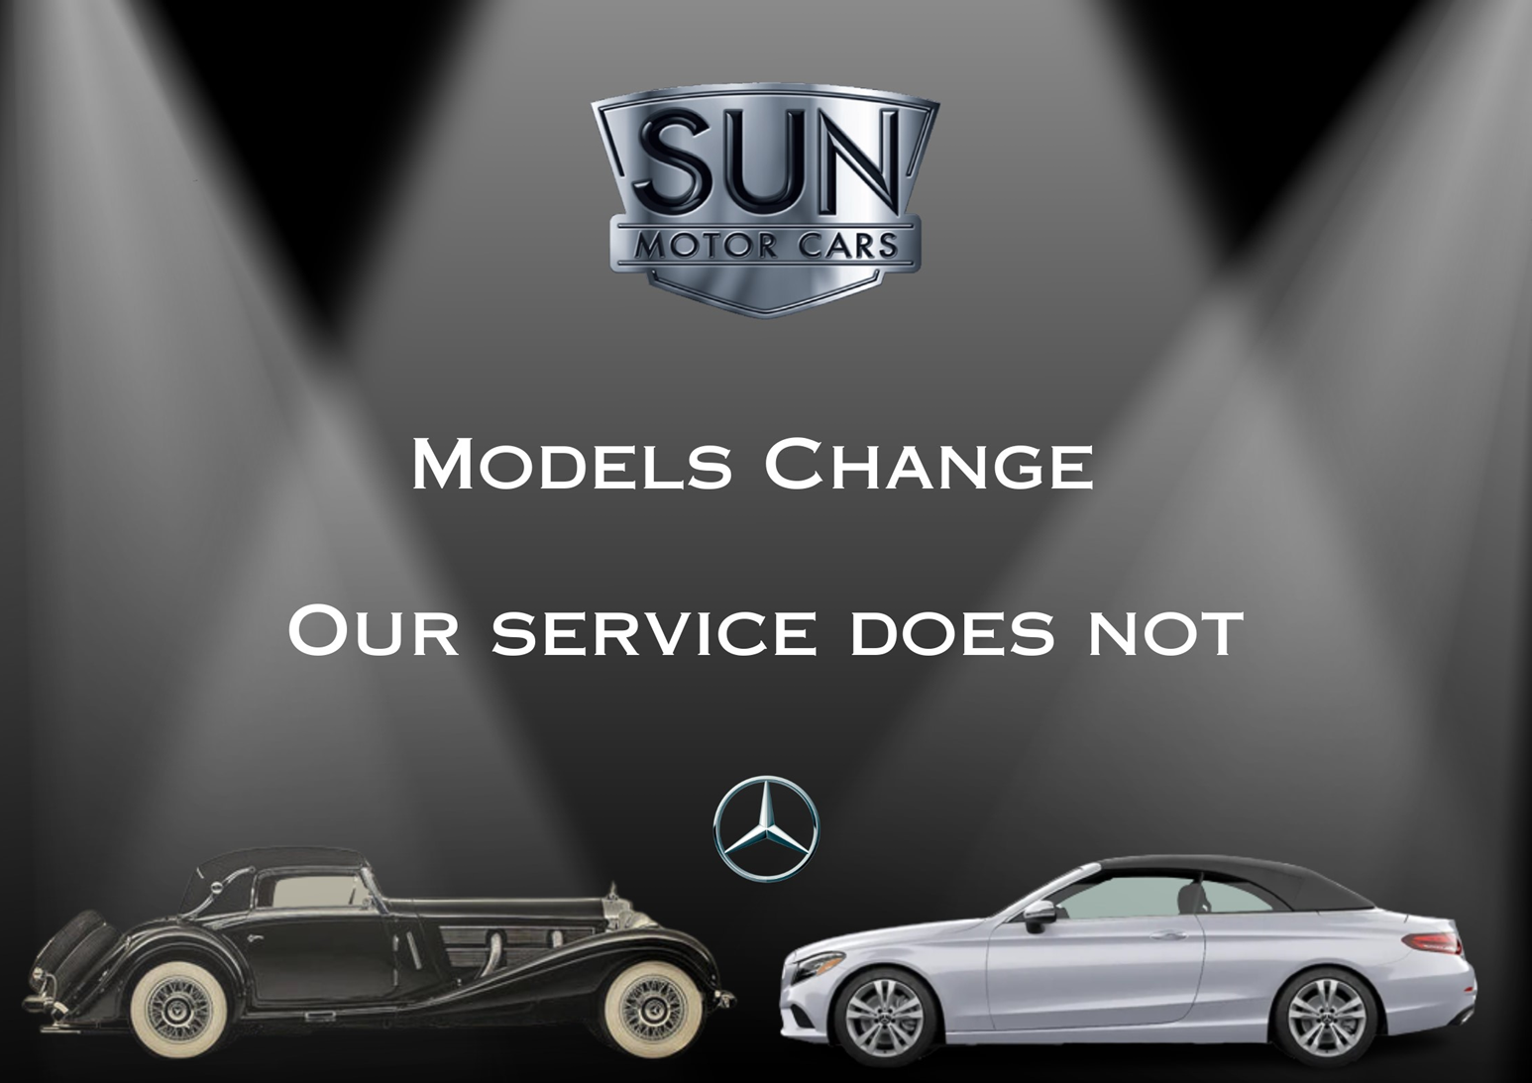

7. REFERENCES (Chloe)
Sun Motor Cars New & Preowned Vehicle Sales: Porsche: Audi: BMW: Mercedes: Sprinter: Serving central pennsylvania. Sun Motor Cars New & Preowned Vehicle Sales | Porsche | Audi | BMW | Mercedes | Sprinter | Serving Central Pennsylvania. (n.d.). https://sunmotorcars.com/
Sun Motor Cars, Inc. (n.d.). Sun Motor Cars, inc.. Mechanicsburg Sun Motor Cars Mercedes | New & Pre-Owned Mercedes-Benz Cars | Serving Camp Hill, Carlisle, Harrisburg & Lancaster. https://www.mercedes.sunmotorcars.com/

